Project explanation:
Built an end-to-end data pipeline using PySpark and AWS. Raw COVID data was stored in S3 (Bronze), transformed into cleaned datasets (Silver), and modeled into analytical fact and dimension tables (Gold). Data was queried using Athena and loaded into Redshift for analytics.

0) Scope (what we’ll build)
S3 layout screenshots
1st screenshot: Rajshreetakeo bucket have covid folder
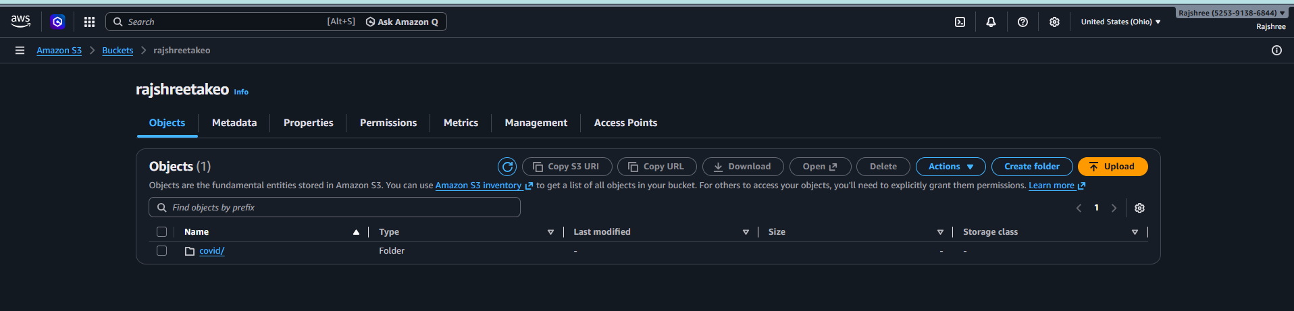
2nd: inside covid folder we have 3 folder: bronze,silver and covid_gold.
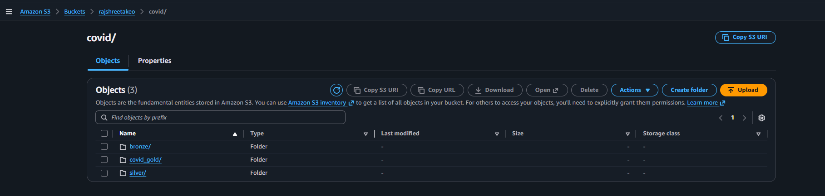
3rd: folders inside bronze folder, and the folder scene in the screenshot has their respective files data.
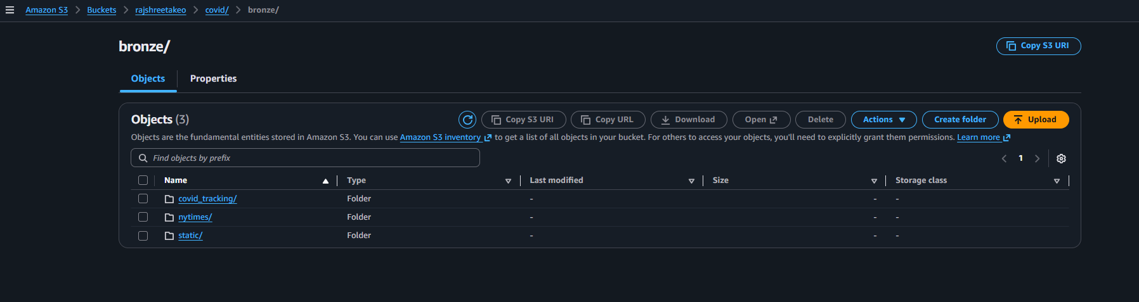
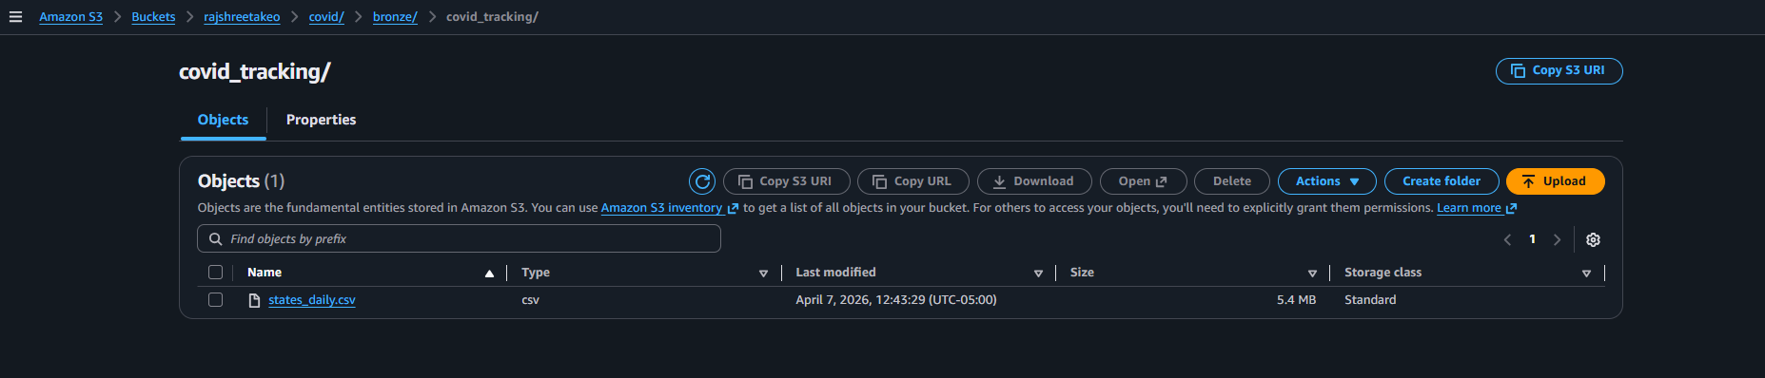
4th screenshot: proof that i have run the code in pycharm
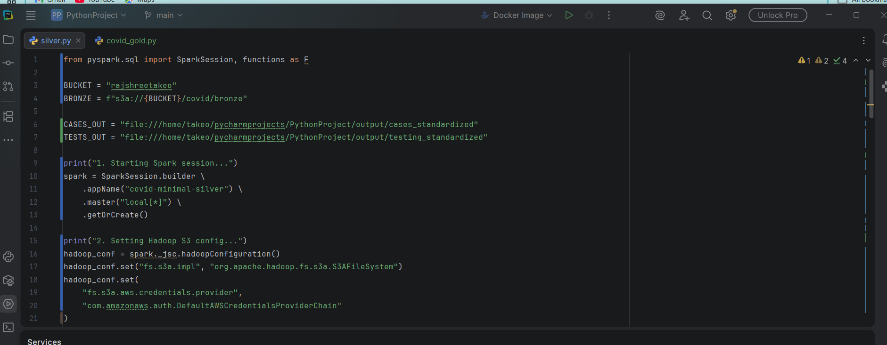
5th screenshot : this shows that spark-submit job
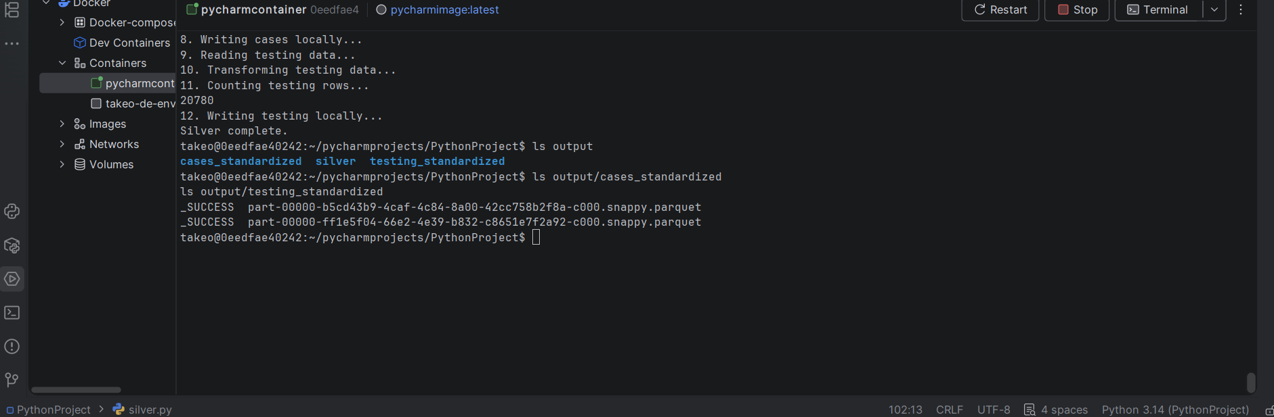
6th screenshot: aws screenshot folder created with files inside, this screenshots show that sparksubmit silver.py job worked.
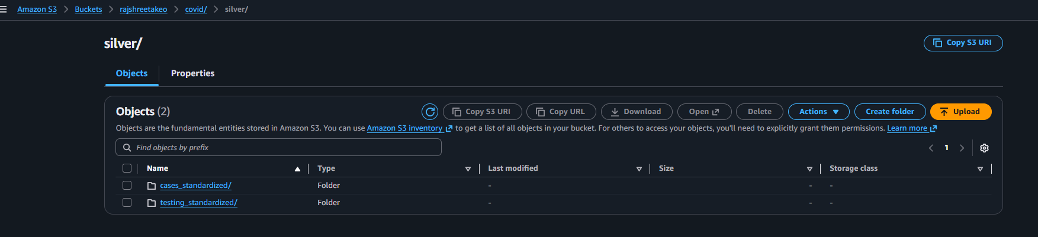
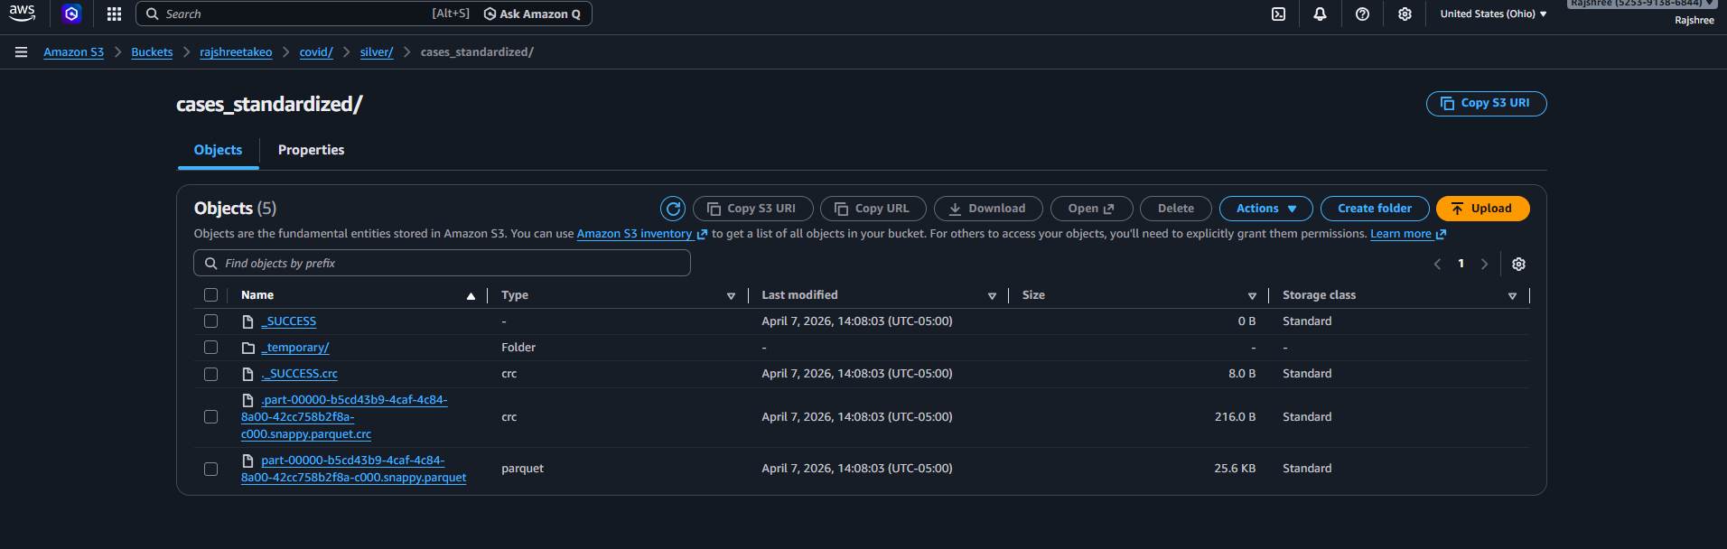
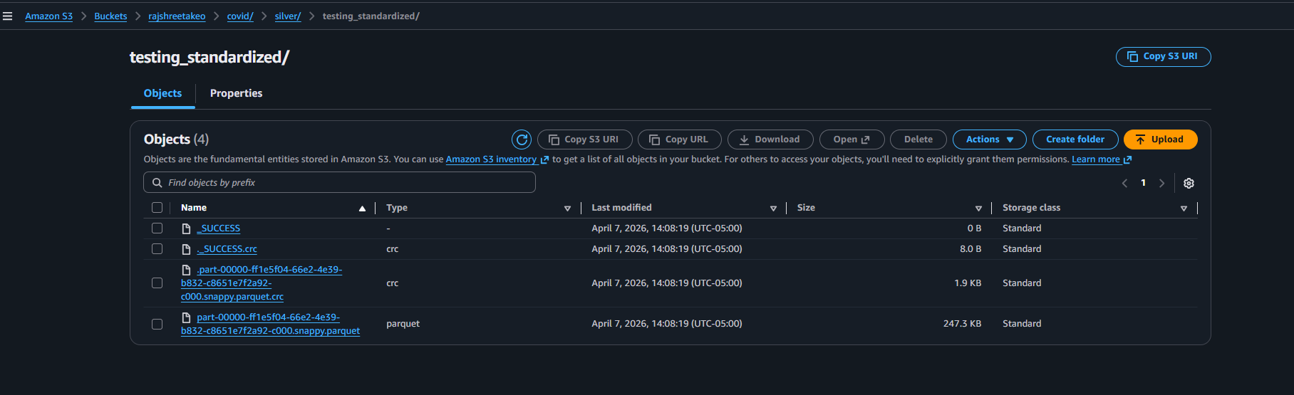

7th screenshot:it shows that gold layer is performed
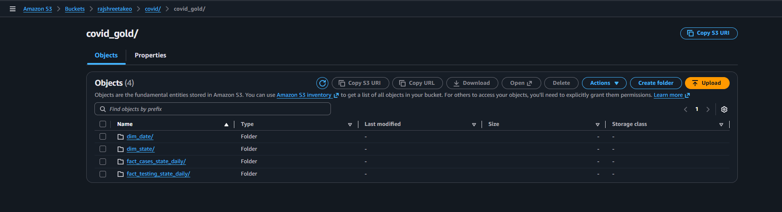
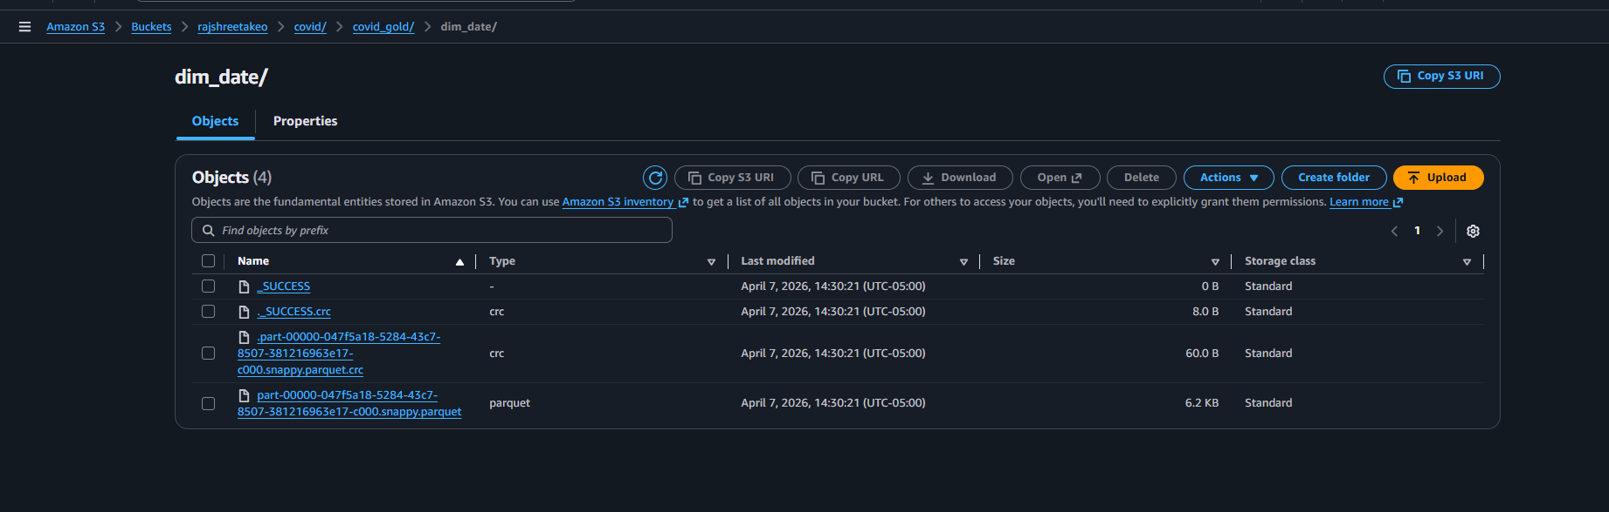
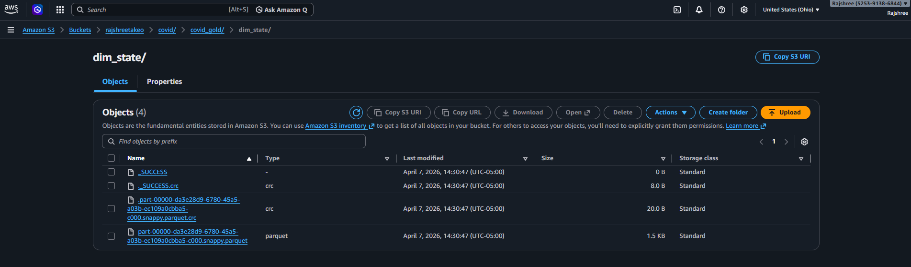
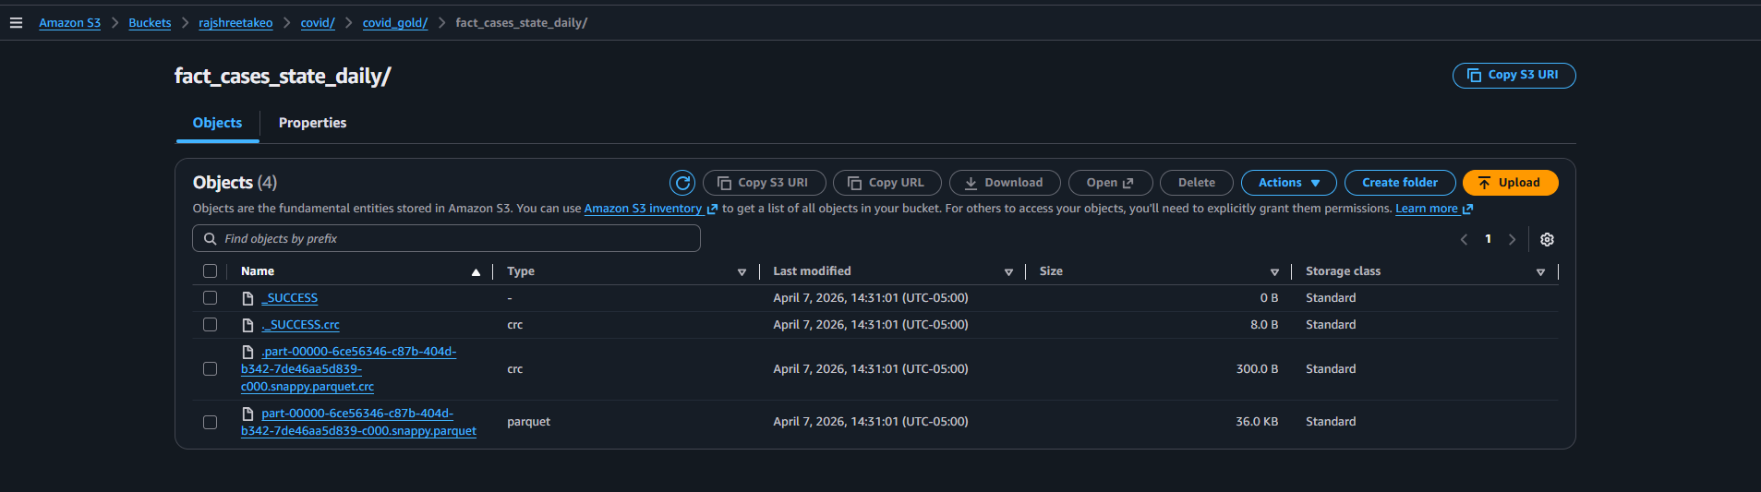
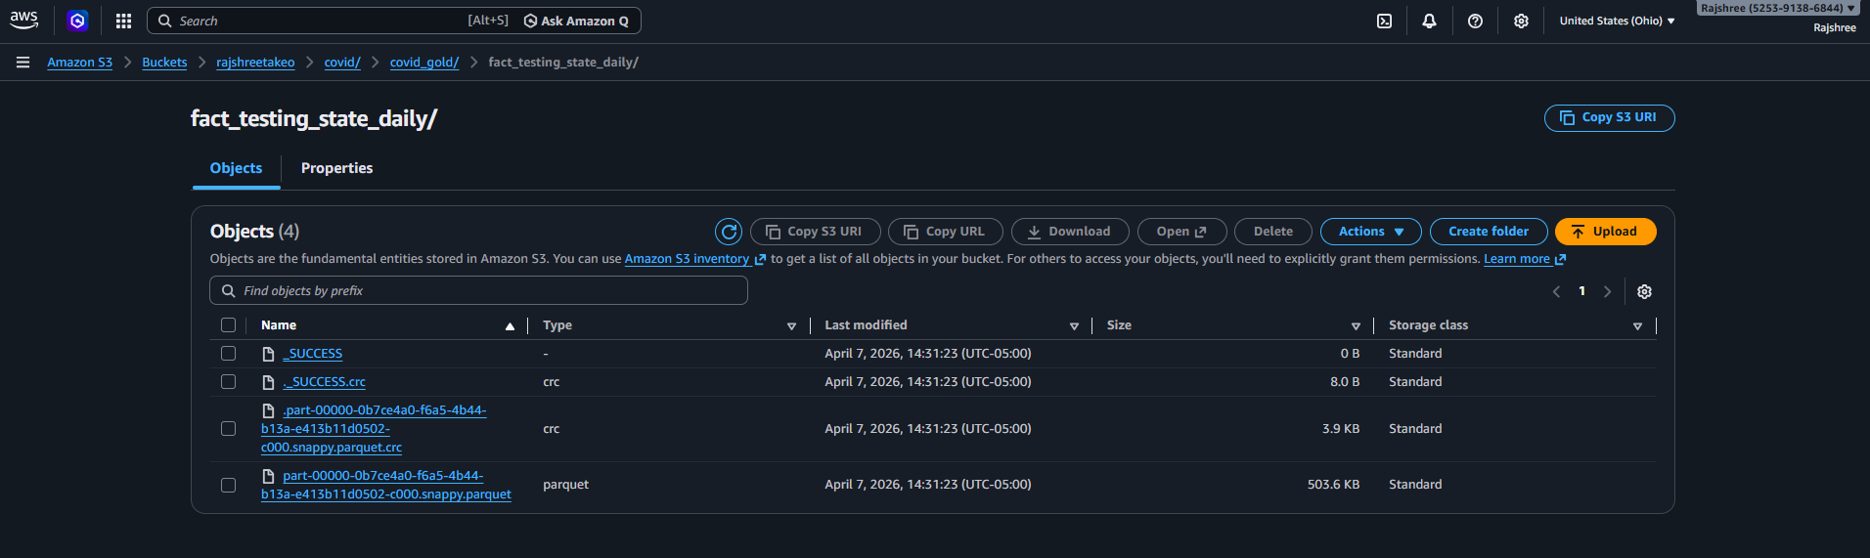

8th screenshot: copy from s3 to redshift
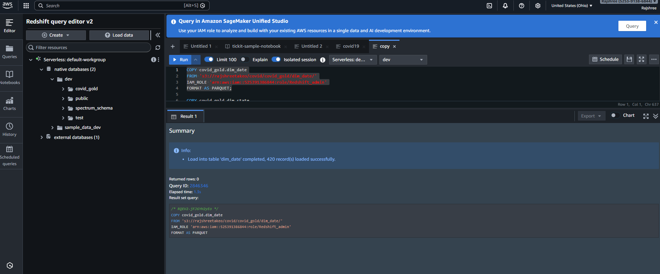
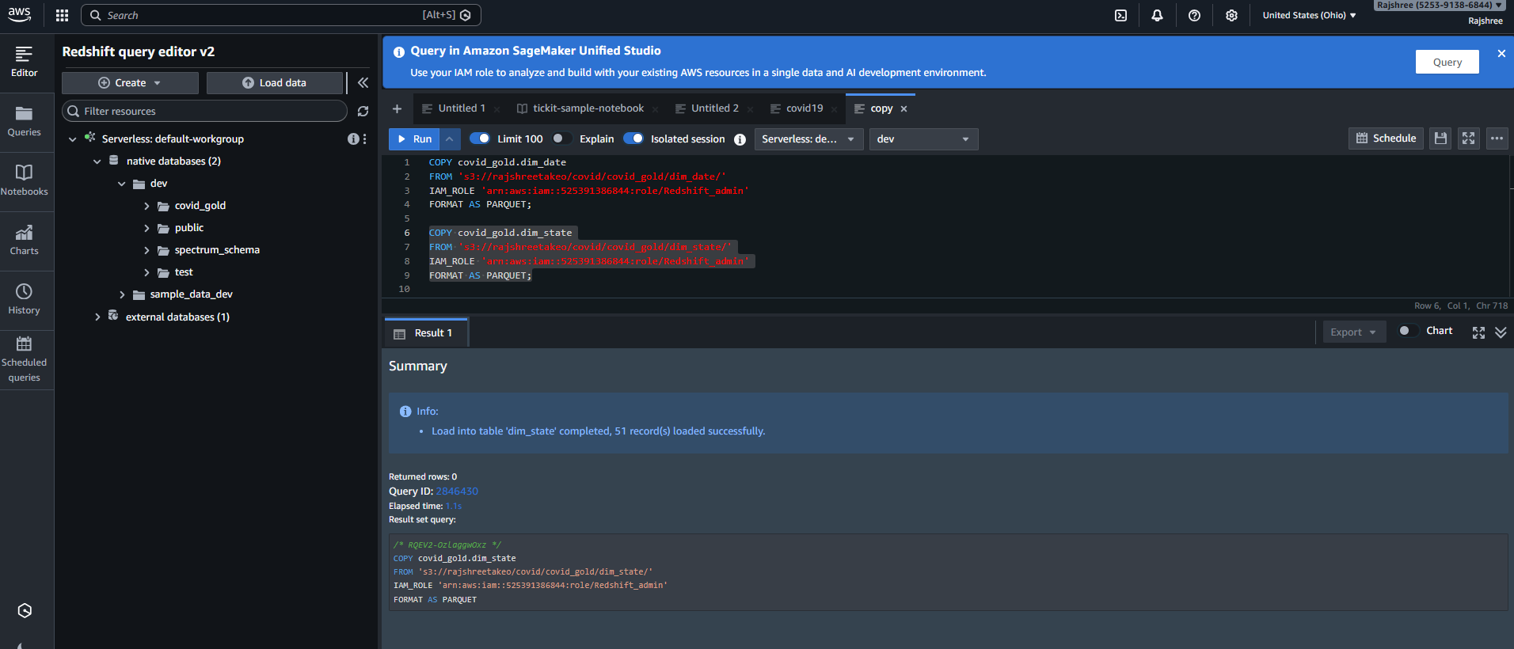
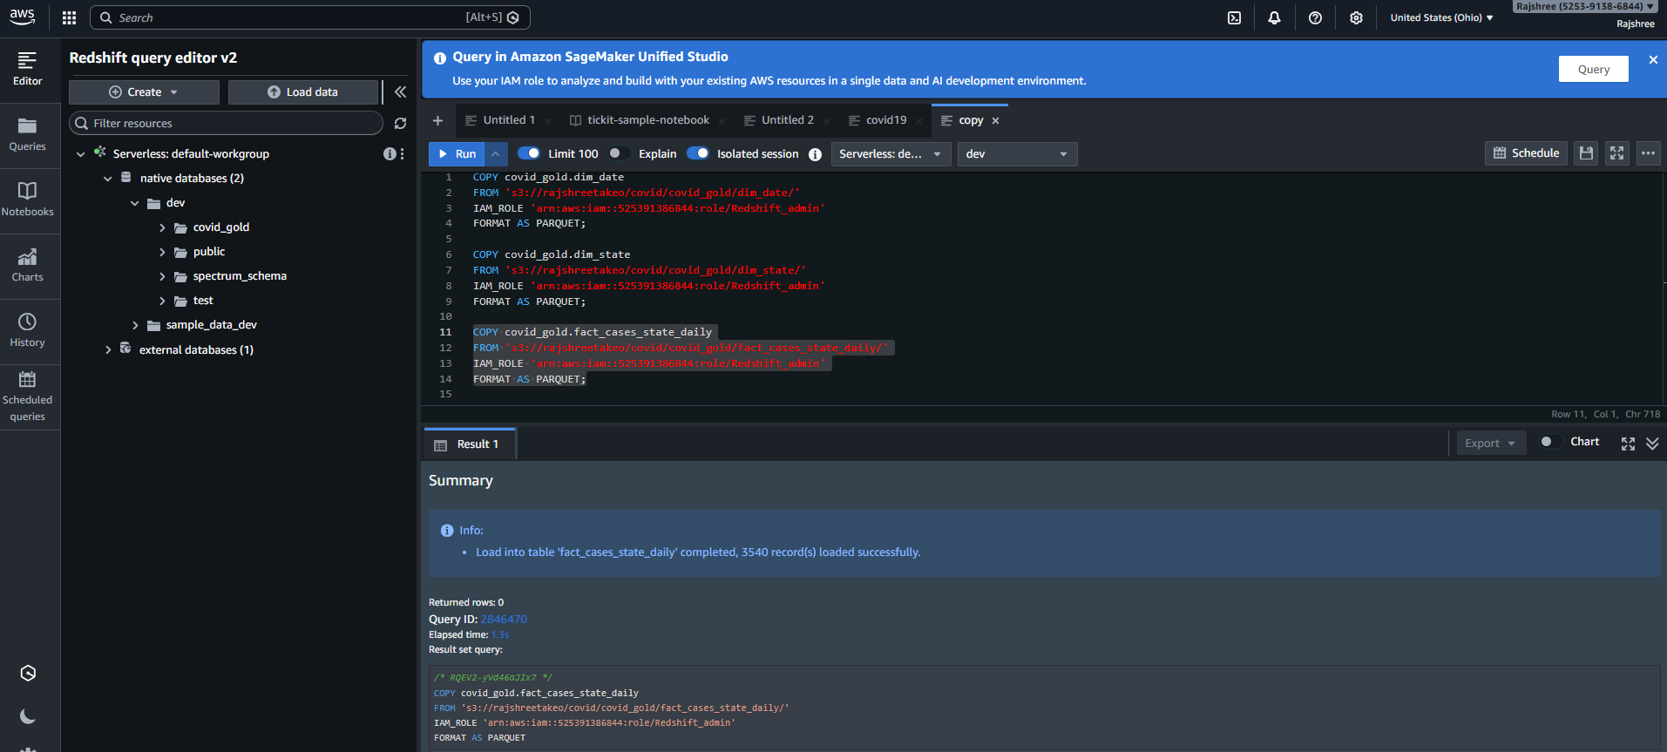
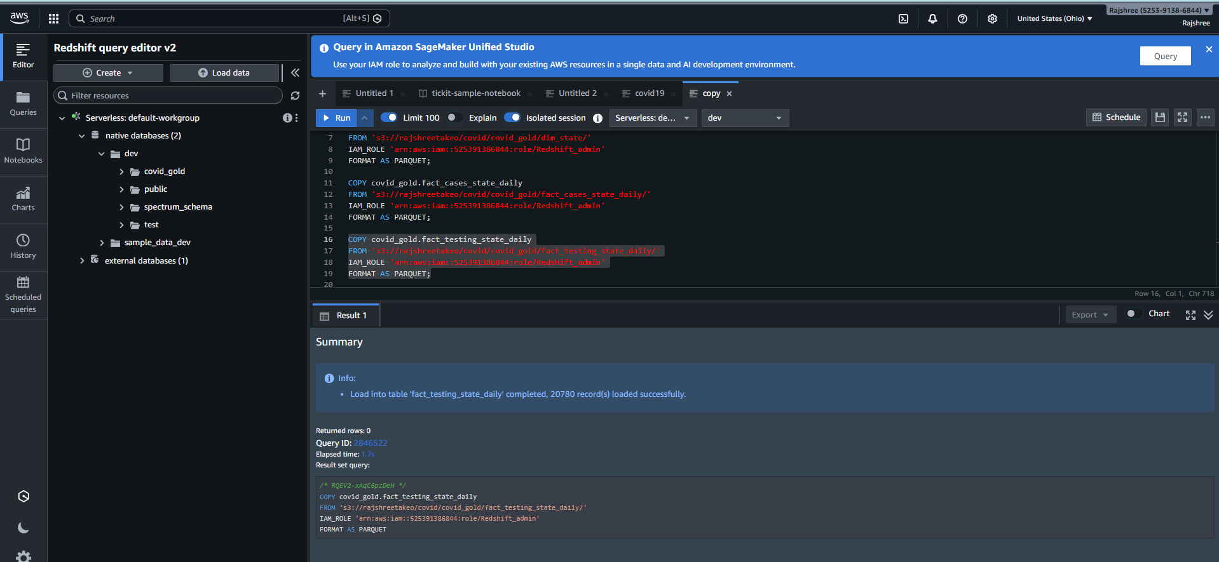

9th: athena output4.1 Top 5 states by new cases on a given date
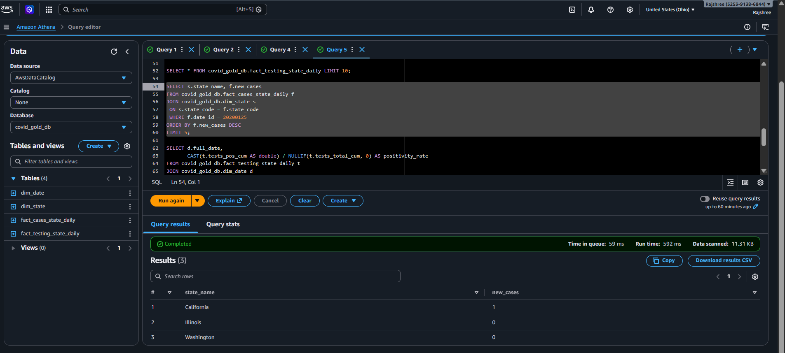

4.2 7-day positivity rate trend for one state
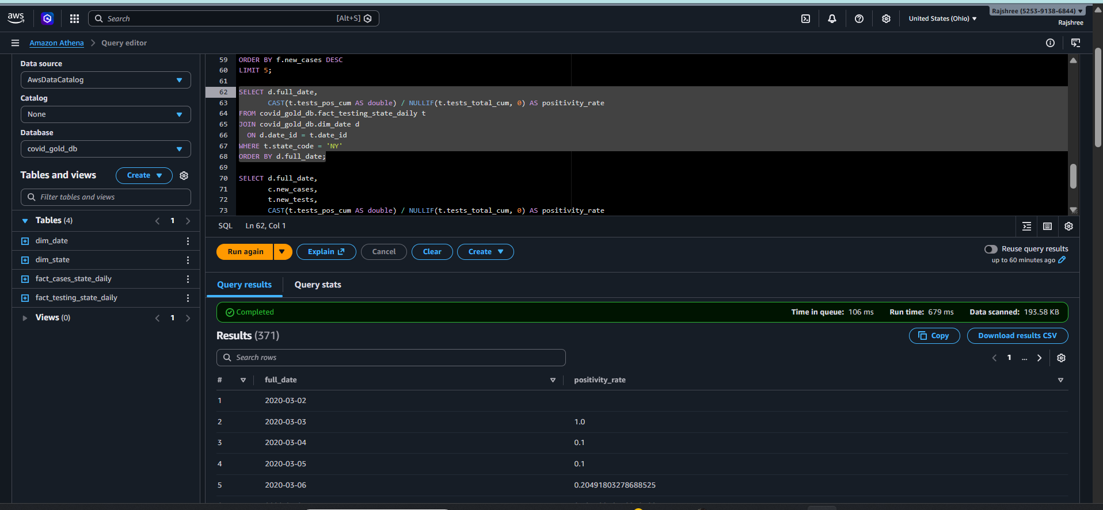
4.3 Daily cases vs tests for a state (sanity/trend)
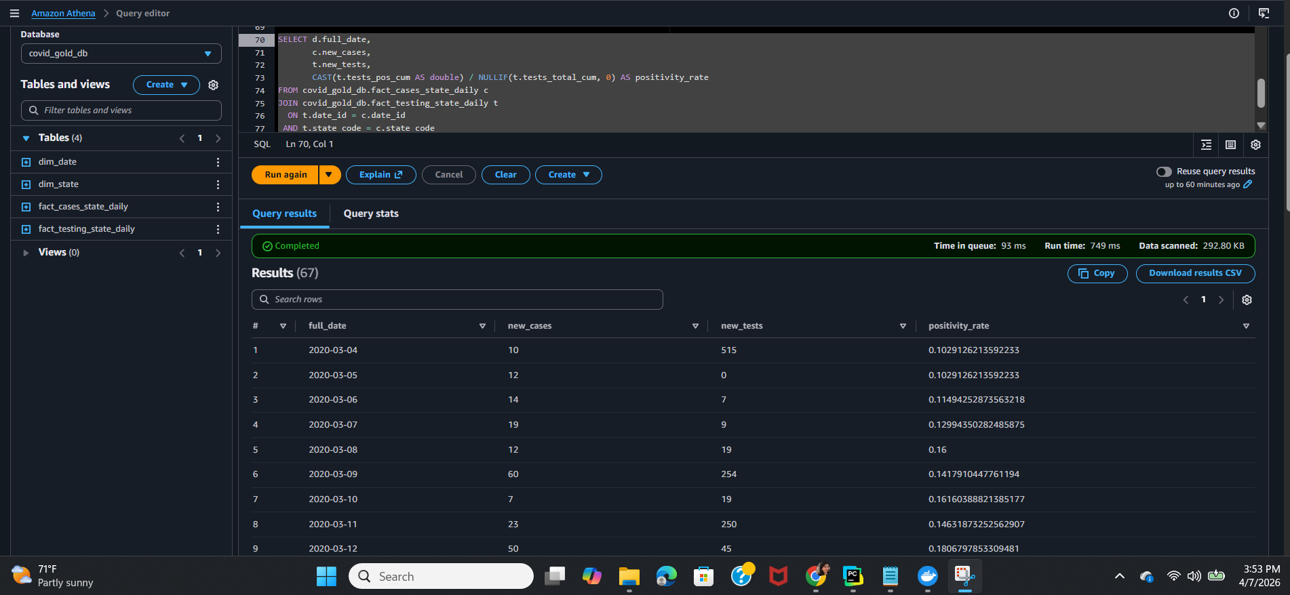

Redshift tables
